Funeral Planning Worksheet

As Christian people, we know that death does not have the final answer. Through God’s grace, Jesus has conquered sin and death forever. As we profess in the Apostles’ Creed, we believe in the resurrection of the body and the life everlasting.

The Evangelical Lutheran Book of Worship States:
At a person’s death, the church shares the grief of those who mourn and remembers the brevity of life on earth. At the funeral we give voice to sorrow, thank God for our loved one, and entrust this companion of ours into the hands of God. Trusting in God’s promise in baptism that we are claimed by Christ forever, we rest in the sure hope of the resurrection. When the church gathers to mark the end of life, Christ crucified and risen is the witness of worship, the strength of mutual consolation, and the hope of healing. – p. 279

In the days following a death, it can often be overwhelming for family members to put the details of a funeral together. Whether it is following a long illness or a surprising accident, your loved ones may wonder what your wishes really were. This worksheet is an opportunity for you to think about these things now, discussing them with your family, friends, and pastor. A copy will be kept at Faith Lutheran to assist the pastor and your family in planning your funeral. It is not a legally binding document, but a guide and starting point for having conversation about what is to come.
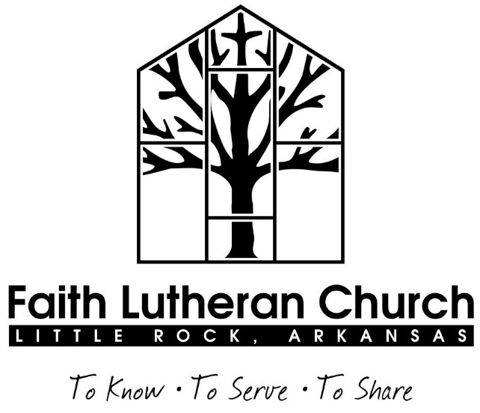

Faith Lutheran Church
7525 West Markham Street
Little Rock, AR 72205
(501) 666-0850
www.faithlutheranlr.org

Basic information
Full name:

Date of birth: Place of birth:

Date of baptism: Place of baptism:

Date of confirmation: Place of confirmation:

Date of marriage: Place of marriage:

Spouse’s name:

Survived by:

Preceded in death by:

Work and education:

Hobbies, activities, and passions:

Next of kin and/or those making funeral arrangements:
Care of the body
This worksheet is not a binding document, but it can guide your loved ones in making decisions. Please talk with your family about these options now. Some decisions require separate signed documents.

Organ donation (circle one): Yes No

Donation for research (circle one): Yes No

Autopsy (circle one):
None unless legally required

If it will benefit medical research

Final decision made by:

Cremation (circle one): Yes, before service Yes, after service No

Have you done any pre planning with a funeral home? (circle one): Yes No

If yes, which funeral home?

Visitation
The visitation is an opportunity for friends and family to gather, often the evening before the funeral.

No visitation Visitation at funeral home Visitation at the church

Funeral service
The pastor of Faith Lutheran normally preaches and officiates at funerals held at Faith Lutheran Church. Other clergy may participate in the service at the pastor’s invitation and discretion. At Faith Lutheran, a white funeral pall covers the casket as a reminder of baptism, and the paschal candle is lit as a reminder of Christ’s triumph over death. Lutherans close the casket once the funeral begins as a sign of resurrection. Communion is very appropriate at Lutheran funerals.

Funeral location (circle one):
Faith Lutheran Church Funeral Home: _____________

Other: ___________

Communion? (circle one): Yes No Unsure

You may choose one Old Testament reading, such as:
Job 19:23-27a: I know that my Redeemer lives
Ecclesiastes 3:1-8: For everything there is a season
Isaiah 25:6-9: God will swallow up death forever
Isaiah 40:1, 6-11: God will gather the lambs
Isaiah 40:1-11, 28-31: Comfort my people, says your God
Isaiah 43:1-3a, 5-7: I have called you by name
Isaiah 43:1-3a, 18-19: I am about to do a new thing
Isaiah 55:1-3, 6-13: Everyone who thirsts, come to the waters
Isaiah 61:1-3: The spirit of the Lord GOD is upon me
Isaiah 65:17-20, 23-25: A new heaven and a new earth
Isaiah 66:10-14: As a mother comforts her child
Jeremiah 31:8-13: I will turn their mourning into joy
Lamentations 3:22-26, 31-33: The steadfast love of the LORD

You may choose a Psalm to be prayed by the congregation, such as:
Psalm 23: The LORD is my shepherd
Psalm 42:1-5: As a deer longs for flowing streams
Psalm 46:1-7: God is our refuge and strength
Psalm 121: I lift up my eyes to the hills
Psalm 139:7-12: The gracious omnipresence of the LORD
Psalm 142:1-6: I cry to the LORD with my voice
Psalm 143: LORD, hear my prayer

You may choose a New Testament reading, such as:
Romans 5:1-11: Peace with God through our Lord Jesus Christ
Romans 8:31-35, 37-39: Who will separate us from the love of Christ?
1 Corinthians 15:12-26: Christ, the first fruits, has been raised
2 Corinthians 4:6-12, 16-18: Treasure in clay jars
1 Thessalonians 4:13-14, 18: Teaching about those who have died
Hebrews 12:1-2: Surrounded by a cloud of witnesses
1 Peter 1:3-9: A living hope through Jesus' resurrection
1 John 3:1-2: See what love the Father has given us
Revelation 7:9-17: God will wipe away every tear
Revelation 21:2-7: I saw the holy city, the new Jerusalem
Revelation 22:1-5: The Lord God will be their light

The pastor will read one Gospel, such as:
Matthew 5:1-10: Blessed are those who mourn
Matthew 11:25-30: I will give you rest
Matthew 18:1-5, 10-14: A child is the greatest in the kingdom
Mark 10:13-16: Let the little children come
Mark 16:1-7: The resurrection of Christ
Luke 24:1-9: The resurrection of Christ
John 1:1-5, 9-14: The light shines in the darkness
John 6:37-40: I will raise them up on the last day
John 10:11-16: I am the good shepherd
John 11:21-27: I am the resurrection and the life
John 14:1-6: I prepare a place for you
John 14:25-27: Peace I leave with you
Music
Through music, we are often able to express what words alone cannot. For services at the church, Faith Lutheran’s Music Director will normally be the musician. In selecting music, it is important to consider how the hymn proclaims Christ crucified and risen as demonstrated in the life of the deceased, as well as feasibility for congregational singing. Recordings or popular tunes might be more appropriate as music at the visitation or luncheon. This list is a starting point, and by no means exhaustive. Choose three to five hymns:

ELW Hymns
Abide with Me 629
A Might Fortress is our God 504
Amazing Grace 779
Beautiful Savior 838
Children of the Heavenly Father 781
For All the Saints 422
Holy God, Holy and Glorious 637
How Small Our Span of Life 636
Give Me Jesus 770
Guide Me Ever, Great Redeemer 618
How Great Thou Art 856
I Know that My Redeemer Lives 619
Lift High the Cross 660
Lord of all Hopefulness 765
My Faith Looks Up to Thee 759
On Eagle’s Wings 787
Precious Lord, Take My Hand 773
Softly and Tenderly, Jesus is Calling 608
The Strife is O’er, the Battle Done 366
Thy Holy Wings 613

You may also elect to have a soloist sing or an instrumentalist play. If you have a particular piece you would like sung or played, please list it here:

Solo or Instrumental Piece: _____________________________________________
Remembrances
Sharing stories and memories can be a helpful way of celebrating and grieving. However, discomfort with public speaking and strong emotions can make this a difficult task for many. The sharing of memories during the service itself should be limited to no more than three preselected people who have prepared their words in advance. An open time for memories is appropriate during the luncheon or with the family following the service.

Memories during the service? (circle one): Yes No
Names (no more than three):

Including others
There are several opportunities for including friends and family in the service.

Pall bearers (up to eight):

Honorary pall bearers:

Readers (up to three):

Ushers (two to four):

Assisting minister:

Funeral luncheon
Faith Lutheran loves to provide food and hospitality at funerals.

No luncheon Food at Faith Lutheran Food at a home or restaurant

If food: Full meal Coffee and dessert Finger food appetizers

Burial
Internment (circle one): In the earth Mausoleum Cremation

If internment in the ground, have you secured a cemetery plot?
(circle one): Yes No Where?

Military honors
Those who have served in the military may be eligible for military honors. A flag is usually placed on the casket after the funeral for transport to the burial. At the graveside, the color guard finishes the military portion before the pastor closes with the committal.

Have you served in the military? (circle one): Yes No

What branch? When?

Memorial gifts
Giving to Faith Lutheran and other charities is a way to ensure that the good work you supported during your life will continue to be supported in your death. Gifts to Faith may be made to the General Fund or to the Memorial Fund. If you would like to make a specified gift to Faith in another way, please speak to the pastor.

I have shared with my next of kin where financial gifts in my memory should be directed. (circle one): Yes No
Recipients include:
____ Faith Lutheran Church (circle one)
General Fund Memorial Fund
____ Other:
____ Other:

Gifts are to be in lieu of flowers (circle one): Yes No

Planned giving (optional section):
I have included Faith Lutheran Church in my will (circle one): Yes No

I have planned another type of deferred gift (circle one): Yes No

Please list: Life insurance, gift-annuity, charitable trust, etc.

If you have circled yes above, you may wish to note the following:

Faith Lutheran Church is included in my estate plan for:

Percentage: _______ % Estimated value of gift: $__________

Fixed amount: $__________

Please share any additional details or requests:

Name of person preparing this form (print):

Signature: Date:

Do you desire a visit with the pastor to discuss these plans? (circle one): Yes No

Please feel free to call upon the pastor at any time for help with issues of death, dying, grief, or mourning.

Please return this worksheet to:

Faith Lutheran Church
7525 West Markham St.
Little Rock, AR 72205
(501) 666-0850
www.faithlutheranlr.org

